Setting up AmazonSmile
Using AmazonSmile for the first time:
- Go to http://smile.amazon.com.
- In “Or pick your own charitable organization,” enter the following EIN:
81-3800641
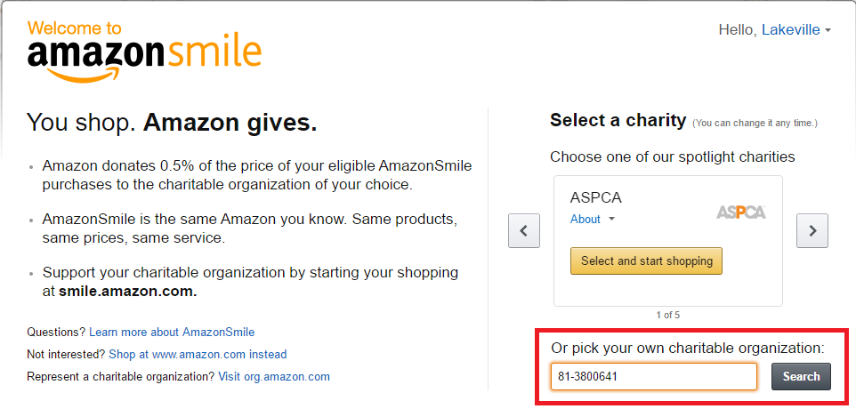
- Click Search.
- Click Select for “Parent Booster USA Inc”
Note: The name will eventually change to Lakeville South High School Band Boosters
- Select “Yes” you understand you must always start at smile.amazon.com to support this organization.
- Click Start Shopping.

Existing AmazonSmile user changing their charity:
If you already use Amazon Smile to support another charity and want to support Lakeville South High School Band Boosters, you can change the organization you support.
- Access http://smile.amazon.com
- Hover over the organization you are currently supporting
- A popup appears with details about your support.
- Click Change next to the name of your current organization. For example:
- In “Or pick your own charitable organization,” enter the following EIN:
81-3800641
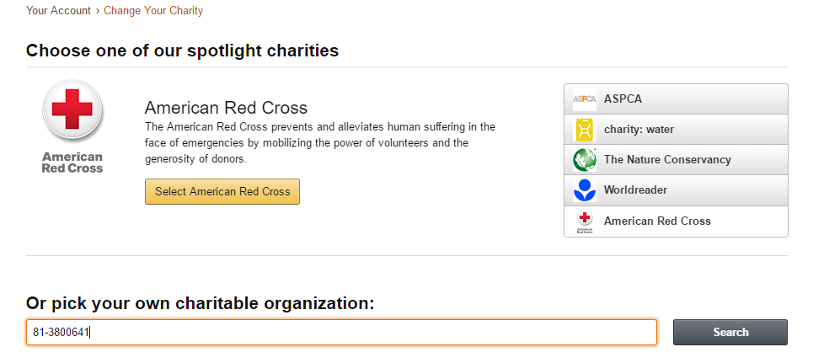
- Click Search.
- Click Select for “Parent Booster USA Inc”
Note: The name will eventually change to Lakeville South High School Band Boosters
- You will get a message that your charity has been successfully changed.

